Metering Installation Error Report

(Data source: explore_1.xlsx. Error calculated: Fri Mar 13 14:03:15 2020.)
The error calculated for the given load profile is +0.14 %.
The expanded uncertainty at an estimated 95% level of confidence is 0.15 %.
The uncertainty interval extends from -0.01 % to +0.29 %.

Installation error over the phase and current ranges that match the load profile.
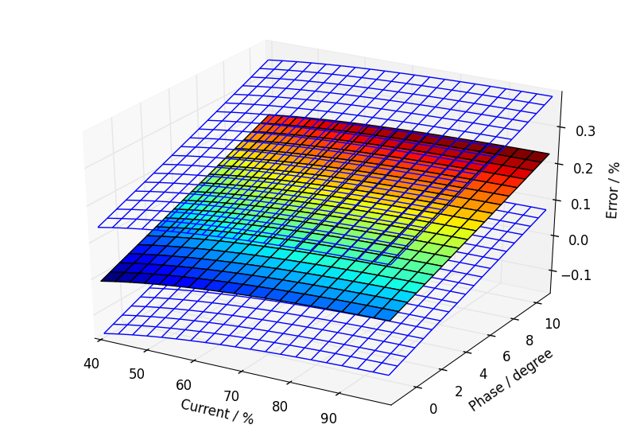

Annual load profile used for this error calculation.
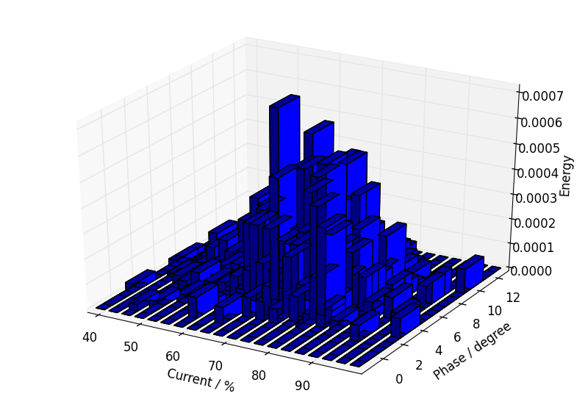

Component calibration data with calculated fits over the calibration ranges.

Current Transformer.
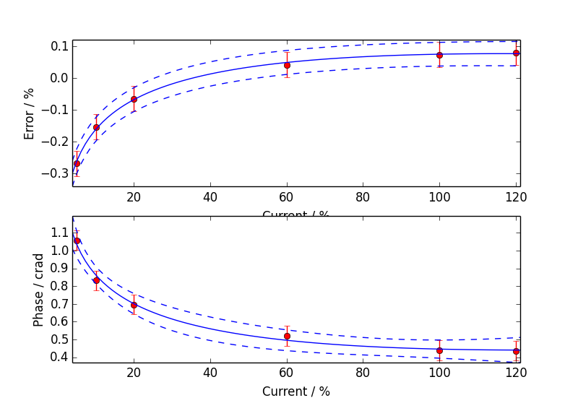

Voltage Transformer.
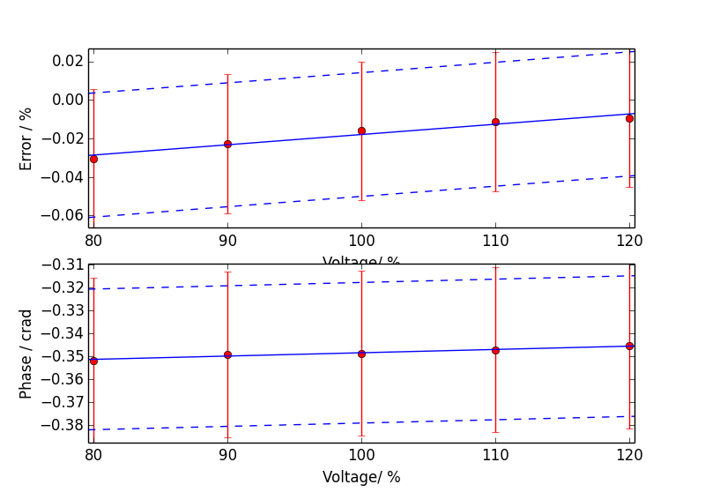

Meter.
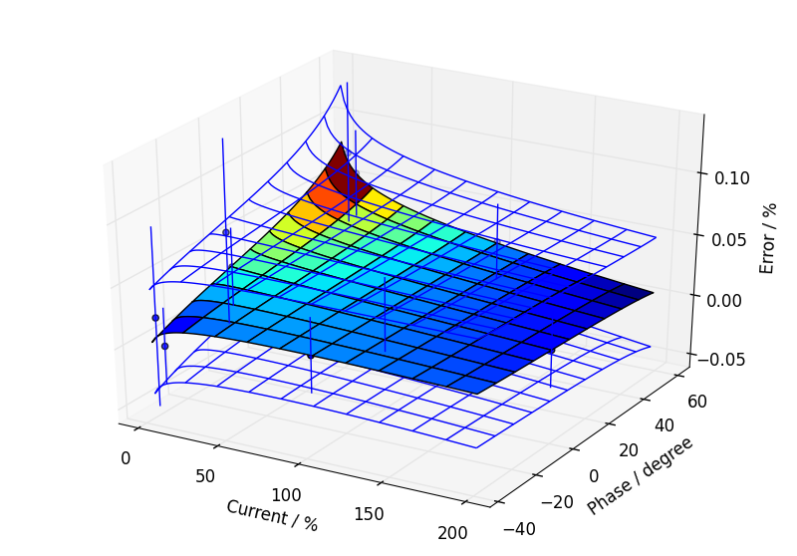

Additional Information

Uncertainty Contribution Summary
Uncertainty contribution by component as a percentage of total variance, Meter: 17 %, CT: 54 %, VT: 29 %.

Text Output From Calculation Process
Meter data
Fit has lower uncertainty than expected from calibration data, so type B component added.
CT ratio data
Fit has lower uncertainty than expected from calibration data, so type B component added.
CT phase data
Good fit.
VT ratio data
Fit has lower uncertainty than expected from calibration data, so type B component added.
VT phase data
Fit has lower uncertainty than expected from calibration data, so type B component added.

Max current = 100.79 %, Min current = 38.36 %, Max phase = 11.30 degrees, Min phase = -2.05 degrees

Budget for overall error by coefficients

0.136, u=0.075, df=106.5
a2 CT_e: 0.0821861
a0 VT_e: 0.0515479
a1 VT_e: 0.05104
a0 CT_e: 0.0418284
a1 CT_e: 0.0363591
Meter temperature coefficient: 0.0357071
Meter harmonic dependence: 0.0282843
Site harmonics: 0.0282843
Site voltage: 0.0227533
Meter voltage dependence: 0.0212132
b0 meter: 0.0202546
b0 CT_e: 0.0183737
b0 VT_e: 0.0163636
Meter frequency dependence: 0.0132583
Site frequency: 0.012499
CT calibration burden: 0.01017
Site CT burden: 0.01017
a0 meter: 0.00824024
Site temperature: 0.00751887
a2 CT_p: 0.00732883
a1 meter: 0.00592367
a0 VT_p: 0.00459336
a1 VT_p: 0.0045481
a0 CT_p: 0.00372727
a1 CT_p: 0.00325002
a3 meter: 0.00164117
b0 VT_p: 0.00139746
a2 meter: 0.00135132
VT calibration burden: 0.00131213
Site VT burden: 0.00131213
CT temperature coefficient of error: 8.07585E-05
CT temperature coefficient of phase: 5.80625E-05
VT temperature coefficient of phase: 4.23896E-05
CT calibration temperature: 3.96631E-05
VT temperature coefficient of error: 2.4479E-05
VT calibration temperature: 5.11731E-06

